**CSE2004 DBMS DPJ - Final Project Submission**

Project on

Digitalized Sweet Shop

Submitted by

Team number - 24

19BCE0470- Ripunjay Narula

19BCE0629- Samvit Swaminathan



School of Computer Science and Engineering,

Vellore Institute of Technology,

Vellore, Tamilnadu, India - 632014

**Help file**

Software used/required: 1) Front end: HTML5, CSS, PHP

2) Database: MYSQL, PHPmyadmin

3) Server: WAMP

4) Any other requirement

Connection string used to connect the front end with database: PHP

PHP code:

$servername = "localhost";

      $username = "root";

      $password = "";

      $dbname = "sweet";

Database details:

No. of tables as per the normalized schema : 12 (includes 2 tables for payment and finance firm)

No. of tables in the final project : 10

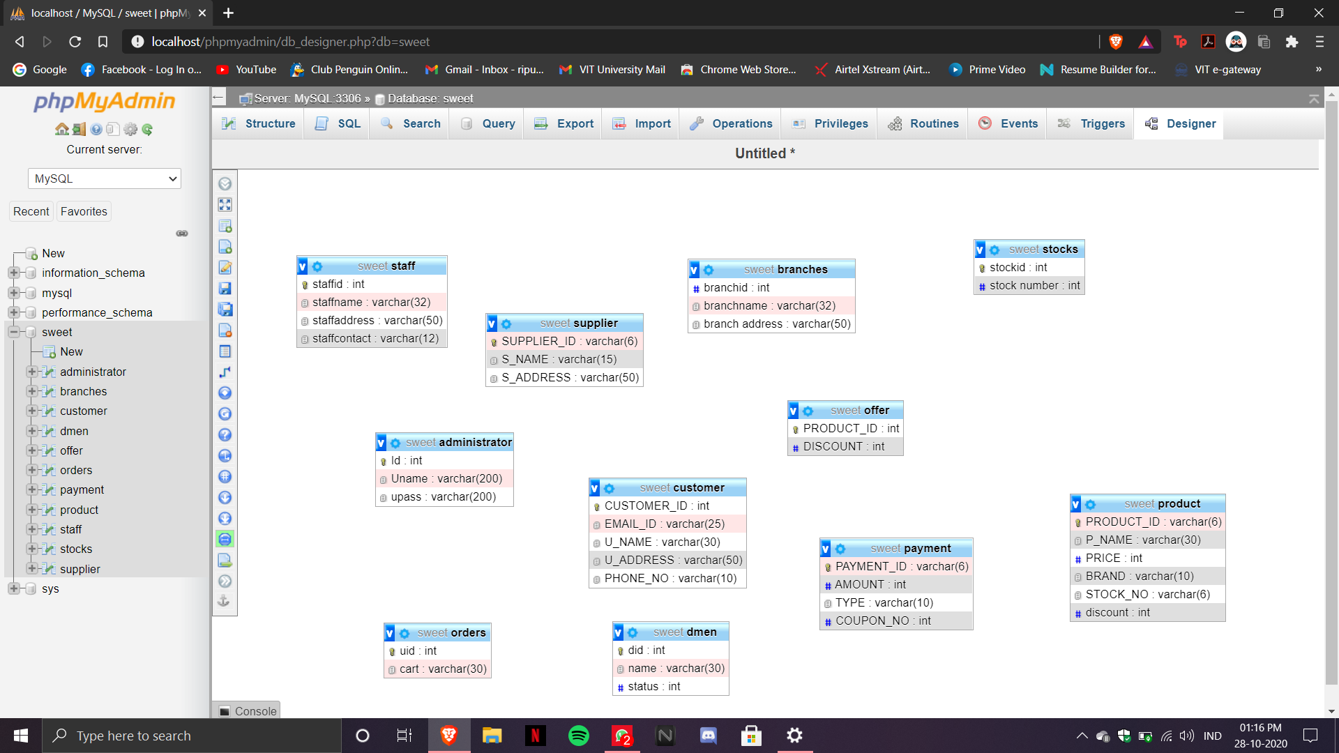

Front end details:

How many interface pages? : 8

Type of interface (web page/application) : Web page

**How to install and test the webpage**

1. Install WAMP server.
2. Run WAMP server on your PC and set the username for PHPmyadmin as ‘root’ and password as ‘’ (blank).
3. Place the folder “Sweet” in your WAMP64 directory’s www folder.
4. Open PHPmyadmin, create a new database named “sweet” and run the SQL file placed inside the folder.
5. Open a browser and in the address bar, type “localhost/sweet/album”.

**User flow of the website**

1. As soon as you enter the website, you will find the list of sweets available.

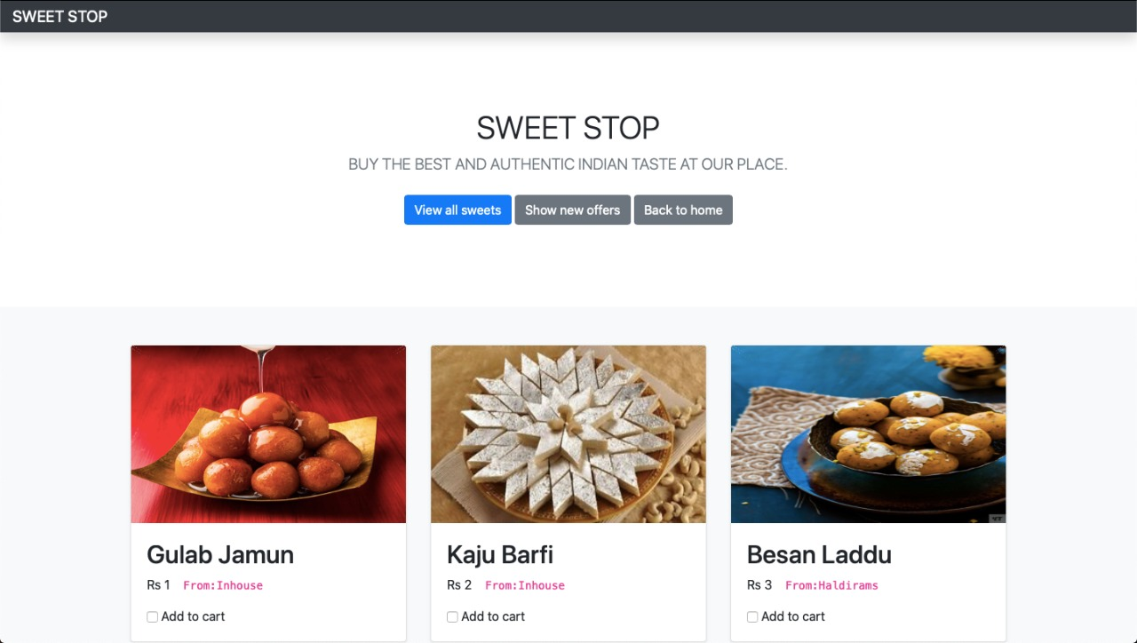

2)Then you can add to cart by choosing the check boxes given to you, under the type of sweet you want.

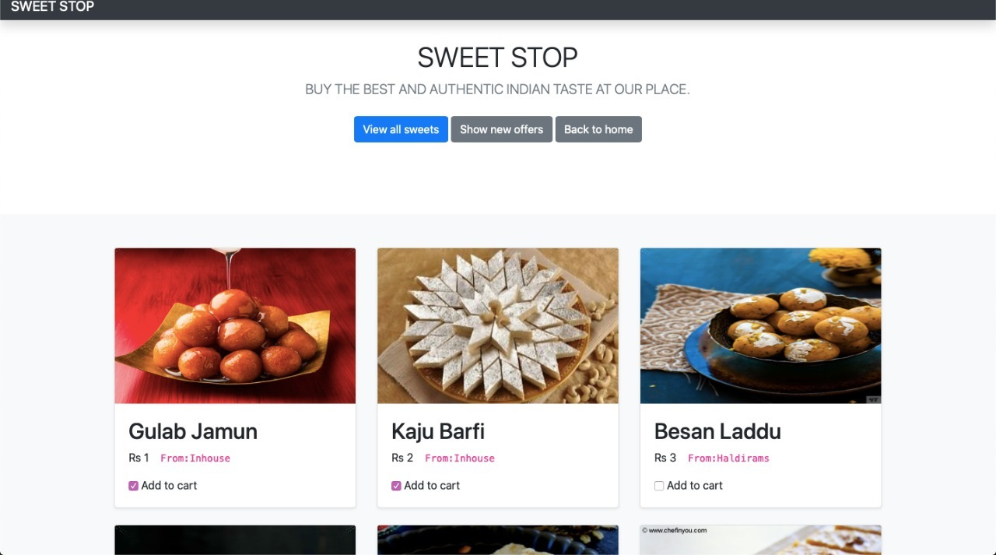

3) Once you click the buy option, it will ask you to enter the details shown above(Name, Email Id, Address). Then click “Place Order” button.

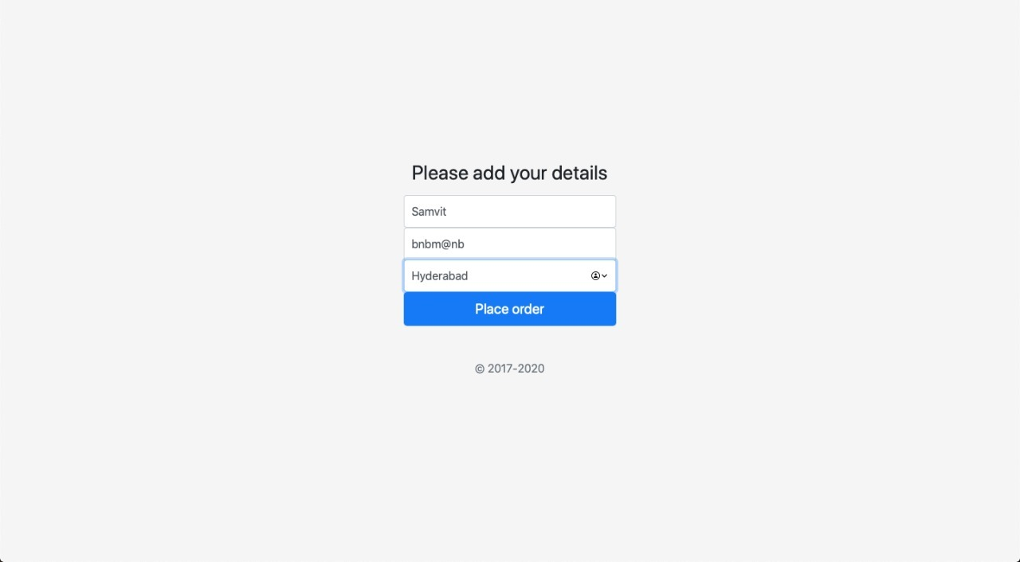

1. Then it will show you your orders and will the total amount that you should pay. At the bottom, it will also show you the delivery boy allotted to you, who will deliver you the sweets.

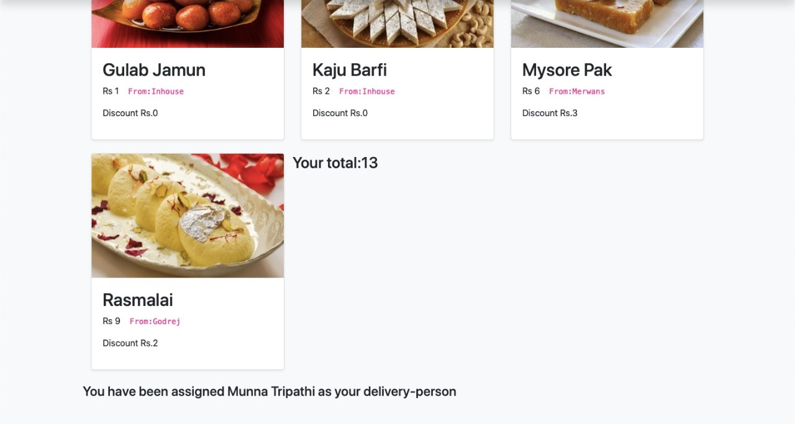

1. At the end of the day, the admin can sign-in to see the amount he/she has earned.

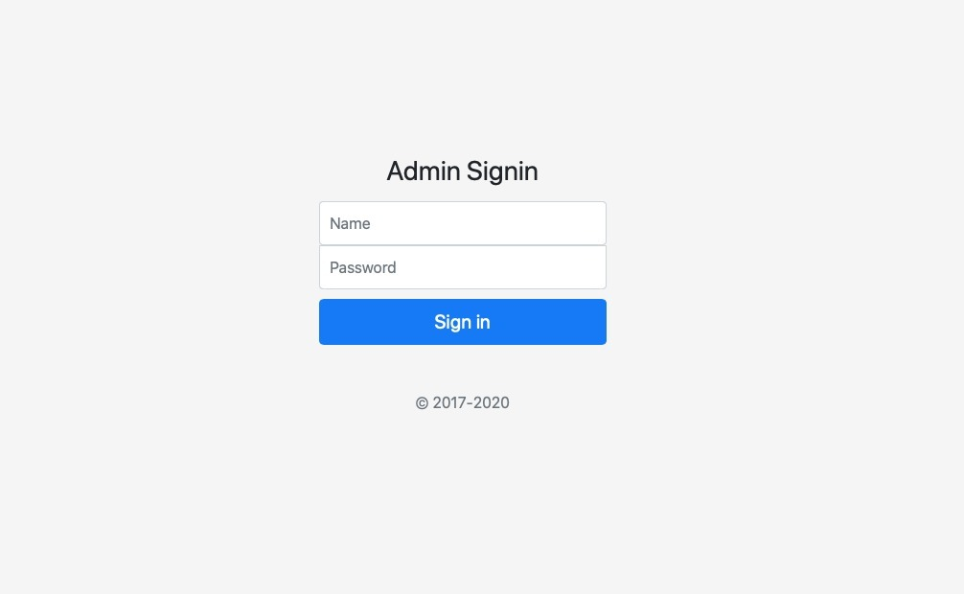

The admin must login with correct Name and Password.

1. If the entered credentials are wrong in the Admin Sign-in, then it show the below pop-up.

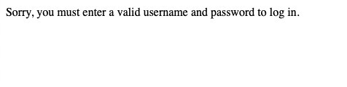7) Once you sign-in successfully in the admin page you can view these details.

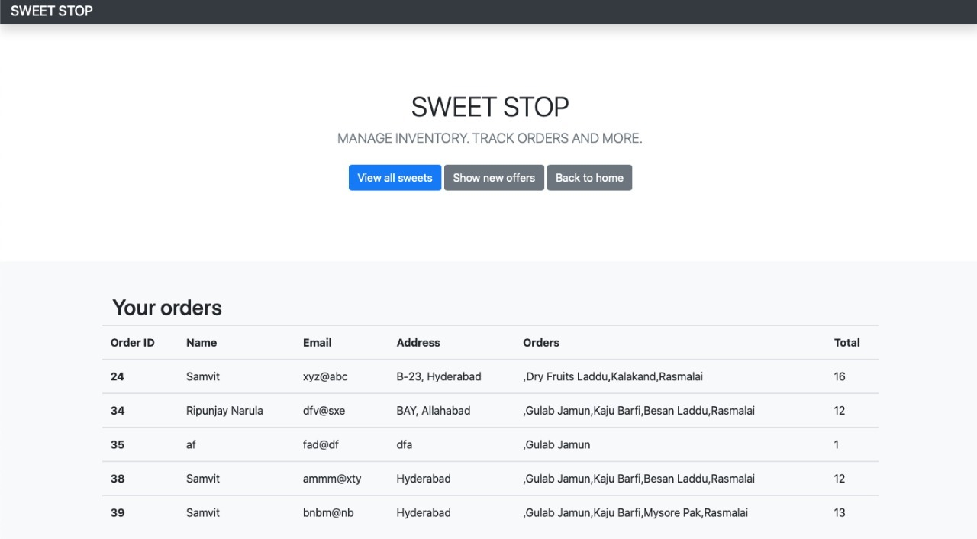

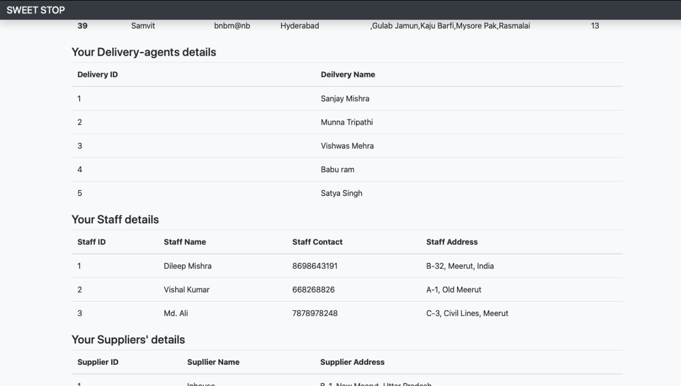

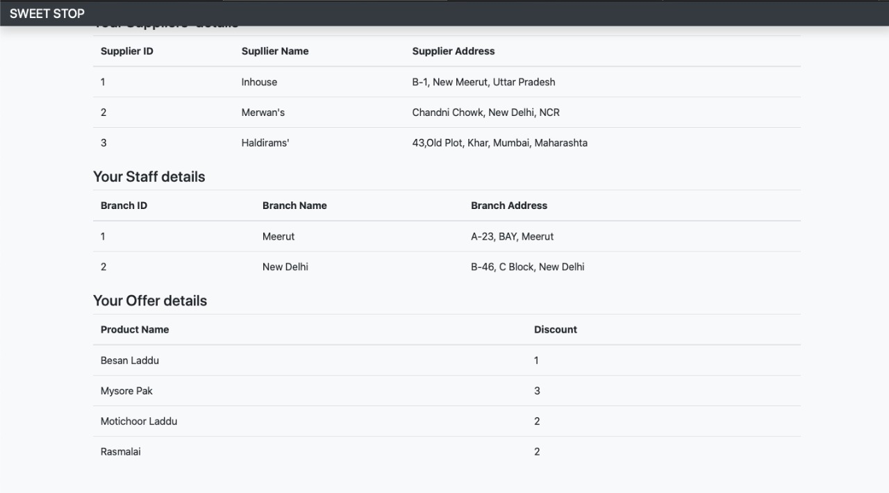

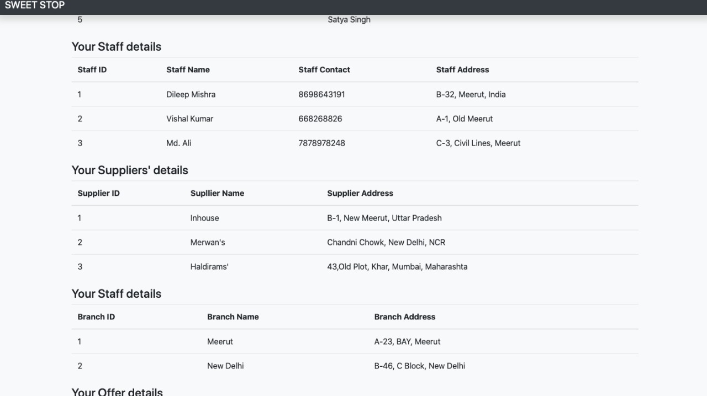

**Phase I report**

**INTRODUCTION**

The following database management system represents the working of an online shopping portal as a company-oriented system. It helps the company in tracking the records of every customer and any product they sell. The company stores all the details of the customers, keeps a record of all the payments made, their respective orders and all the offers they provided. The product can be found even in the inventory and can be seen by the financial firm too. This will also help the shops to increase their business during COVID-19 situation and cover the loss they faced during the lockdown.

Here every customer detail will be recorded i.e. name, age, email ID, password, address, phone number etc. Each customer shall have a customer ID to uniquely identify their transactions.

A list of products purchased by a customer is available and identified using product ID. The product history from the inventory could also be traced via stock-type. For analysis, finance firm uses composite primary keys to identify and rectify the records. For transparency policy the company also maintains supplier records with a unique supplier ID. Thus, a particular ID is provided to all the users in their respective fields due to which tracking them will be easy.

For checking the transaction details company can rectify the payments made by a customer with the help of a unique payment ID. Through payment details, the company can track the offers applied for the payment and the discount gained.

The placed order will be mentioned in order table with unique order ID and will also show order date and expected date of product delivery.

The branch of the shop will also be mentioned with its address and pin code.

To track the spread of COVID-19, the details of the delivery person will also be mentioned along with his/her phone number so that they can be contacted and informed of the spread.

The design for this company-oriented database management system is made by keeping in mind:

* Persistence in database
* Removing anomalies and performing various operations
* Usage of minimum amount of memory
* To avoid redundancy
* Smooth database and easy tracking methodology
* Providing concurrent user interface

# DATA AND FUNCTIONAL REQUIREMENTS

**Customer details**:

The website is based around them. They are also the biggest part of our website. This is where a client’s information is stored. This will store basic info of the customer, such as a unique ID, name, age, username, address, phone number, contact email, password.

**Product details**:

This stores the information about the product. This has a unique ID, name, price, brand.

**Order details**:

Any order that is placed on this website needs to be stored as an invoice for future references. The order may include a unique order ID, order date, and expected date of delivery of the order.

**Delivery Person details:**

The information of the person who will be delivering your product to you will be listed so that if you catch COVID-19 disease, it can be tracked and required measures taken.

**Branch Details:**

The branch of the shop from which your order is being delivered will be shown with its address and pin code so that if you like, you can personally go and shop from there.

**Payment details:**

The details about payments done for the orders will be stored here. We store the unique payment ID, amount paid and mode of payment (type).

**Supplier details:**

The details about the suppliers, i.e. the person/company that wishes to sell their products through this website, will be stored here. The details stored will be name, supplier ID and their address.

**Inventory details:**

The suppliers’ inventory information will be stored here. The stock type, stock name and stock number will constitute this data.

**Finance firm**:

This is the finance department’s data. The details stored here will be firm type, firm ID and the tax associated with the purchase.

**Oﬀers:**

This will cover the oﬀer and discounts of various types that are available on a product. Here we will store the coupon number and the discount received on application of this coupon.

ER Diagram:

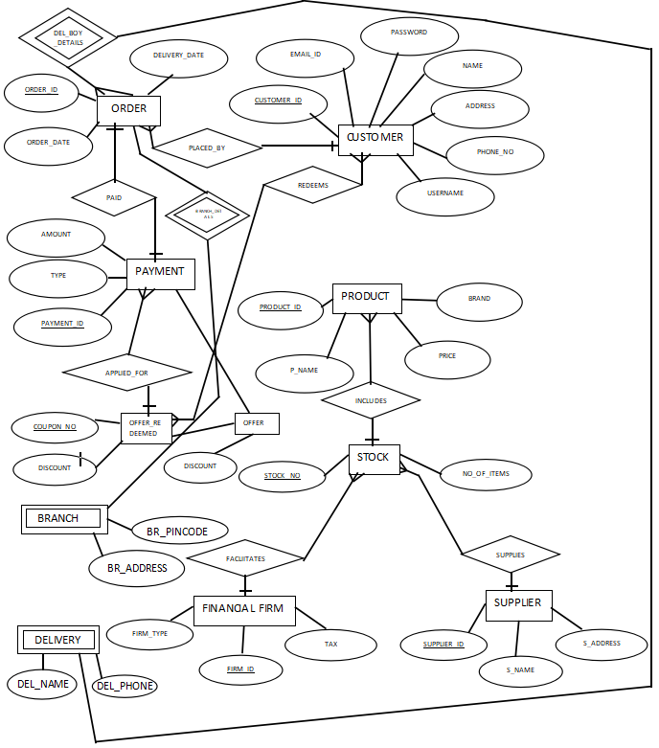

## Functional requirements:

**Data retrieval:**

1. Customers can access products and view the details.
2. Customers can also view their order and payment details.
3. The list of products included in a stock can be retrieved.
4. The list of stocks that a supplier provides can be retrieved.
5. The list of orders place by a customer can be retrieved.
6. The list of offers availed by a customer can be retrieved.
7. The list of stocks that a finance firm facilitates can be retrieved.
8. The list of different payments that availed a oﬀer can be retrieved.

**Data modification:**

1. A customer can modify his/her details such as the address or phone number, if it needs an update.
2. A product’s details can be changed, such as its price.
3. An oﬀer can be modified if the discount it offers changes.
4. A finance firm can change its details, such as the tax it levies.

**Data removal:**

1. A customer can delete his/her account and the data associated with it.
2. An order can be deleted if the customer wishes to cancel it.
3. A product can be deleted from the database if it is no longer available.
4. A supplier can delete their account if they no longer wish to supply their products to the company.

**DOMAIN RESTRAINTS**

* Customer ID: String starting with ‘C’ followed by 5 digits
* Customer username: String which is unique and consists of 8 characters.
* Customer name: String
* Customer address: String of length around 50
* Customer contact number: String of length “10”
* Customer email ID: String of the form "[xyz@example.com](mailto:xyz@example.com)"
* Customer password: String consisting of a combination of letters and digits, with at least one uppercase letter, one lowercase letter, and one digit.
* Product ID: String starting with ‘PR’ followed by 4 numbers
* Product name: String
* Product price: Floating value/ Number
* Branch Pin Code: 6 digit long number
* Product brand: String recognizing a brand
* Supplier ID: String starting with ‘S’ followed by 5 numbers
* Order ID: String starting with ‘O’ followed by 5 numbers
* Order date: Date
* Expected delivery date: Date
* Payment ID: String starting with ‘P’ followed by 5 numbers
* Amount paid: Number
* Payment type: String
* Coupon number: String starting with ‘DIS’ followed by 5 numbers
* Discount percent: Number greater than zero and less than 100
* Supplier name: String
* Stock type: String
* Stock number: Integer value/ Number
* Firm type: String
* Tax percent: Number that lies between 0 and 100
* Delivery Person’s Phone Number: should be 10 digits long number

**ENTITY RELATIONS**

1. The relationship PLACED_BY exists between CUSTOMER and ORDER. Cardinality ratio is 1:N for CUSTOMER to ORDER.
2. The relationship PAID exists between ORDER and PAYMENT. Cardinality ratio is 1:1 for ORDER to PAYMENT.
3. The relationship APPLIED_FOR exists between OFFER and PAYMENT. Cardinality ratio is 1:N for OFFER to PAYMENT.
4. The relationship REDEEMS exists between OFFER and STUDENT. Cardinality ratio is N:M for OFFER to STUDENT.
5. The relationship INCLUDES exists between STOCK and PRODUCT. Cardinality ratio is 1:N for STOCK to PRODUCT.
6. The relationship SUPPLIES exist between STOCK and SUPPLIER. Cardinality ratio is N:1 for STOCK to SUPPLIER.
7. The relationship FACILITATES exists between STOCK and FINANCE_FIRM. Cardinality ratio is N:1 for STOCK to FINANCE_FIRM.
8. The relationship BRANCH_DETAILS exists between ORDER and BRANCH. Cardinality ratio is 1:1 for ORDER to BRANCH.
9. The relationship DEL_BOY_DETAILS exists between ORDER and DELIVERY. Cardinality ratio is N:1 for ORDER to DELIVERY.

**ER DIAGRAM REDUCTION TO SCHEMA:**

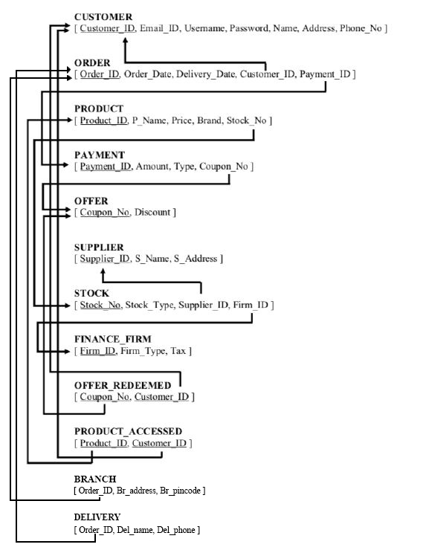

**NOTE**: BRANCH and DELIVERY are only till the pandemic extends so they are not permanent and can be removed without affecting the working of the shop/business that much.

**RULES FOR CONVERTING ER DIAGRAM INTO SCHEMA:**

* **Entity type becomes a table**
* **Every single-valued attribute becomes an element of the table**
* **A key attribute of the entity type represented by the primary key**
* **The multivalued attribute is represented by a separate table**
* **Derived attributes are not considered in the table**

**Phase II report**

**ORDER:**

|  |  |  |  |  |
| --- | --- | --- | --- | --- |
| **Order_ID** | **Order_Date** | **Delivery_Date** | **Customer_ID** | **Payment_ID** |
| **O00001** | **12-AUG-2020** | **20-AUG-2020** | **C00001** | **P00001** |
| **O00002** | **12-AUG-2020** | **14-AUG-2020** | **C00002** | **P00002** |
| **O00003** | **13-AUG-2020** | **20-AUG-2020** | **C00003** | **P00003** |
| **O00004** | **14-AUG-2020** | **17-AUG-2020** | **C00004** | **P00004** |
| **O00005** | **14-AUG-2020** | **15-AUG-2020** | **C00001** | **P00005** |

**CHECKING FOR FUNCTIONAL DEPENDENCIES:**

**{Order_ID} --> {Order_Date}**

**{Order_ID} --> {Payment_ID}**

**{Order_ID, Customer_ID} --> {Payment_ID}**

**{Order_ID} --> {Delivery_Date}**

**{Order_ID } --> {Customer_ID}**

**First Normal Form- If a relation contain composite or multi-valued attribute, it violates first normal form, or a relation is in first normal form if it does not contain any composite or multi-valued attribute. A relation is in first normal form if every attribute in that relation is singled valued attribute.**

**=> Table is in 1NF**

**Second Normal Form- Second Normal Form (2NF) is based on the concept of full functional dependency. Second Normal Form applies to relations with composite keys, that is, relations with a primary key composed of two or more attributes. A relation with a single-attribute primary key is automatically in at least 2NF. A relation that is not in 2NF may suffer from the update anomalies.**

**=> Table is in 2NF**

**Third Normal Form- A relation that is in First and Second Normal Form and in which no non-primary-key attribute is transitively dependent on the primary key, then it is in Third Normal Form (3NF).**

**=> Table is in 3NF.**

**Boyce-Codd Normal Form- A relation is in BCNF, if and only if, every determinant is a Form (BCNF) candidate key.**

**=>Table is in BCNF.**

**\*NOTE: The decomposition is completely lossless.**

**FINAL NORMALIZED SCHEMA:**



**Phase III report**

**SWEET STOP- DIGITALIZED SWEET SHOP**

**FINAL SCHEMA:**



**TO USE THE SOFTWARE, WE NEED ANY SERVER WHICH CAN RUN PHP AND MYSQL. RECOMMENDED TOOLS ARE**

**wampServer(For Windows) mampServer(For macOS)**

**Below is the installation direction for the server**

# Prerequisites for WAMP Server

In order to successfully install and run the WAMP Server, make sure that you must have Microsoft Visual C++ Redistributable packages installed in your system.

1. Microsoft Visual C++ 2008 Redistributable Package (x64)
2. Microsoft Visual C++ 2010 Redistributable Package (x64)
3. Visual C++ Redistributable for Visual Studio 2012 Update 4
4. Visual C++ Redistributable Packages for Visual Studio 2013
5. Visual C++ Redistributable for Visual Studio 2015
6. Microsoft visual c++ 2017 redistributable package

# Installation Process of WAMP Server

## Step 1

To download the WAMP Server, visit the "Wamp Server" website in your web browser.

## Step 2

Click on the "WAMP SERVER 64 BITS (X64).

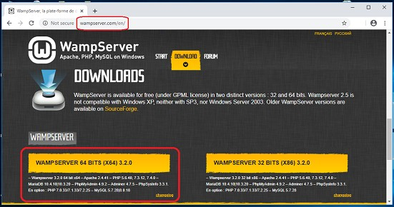

## Step 3

Now, click on the "download directly" link to start downloading.

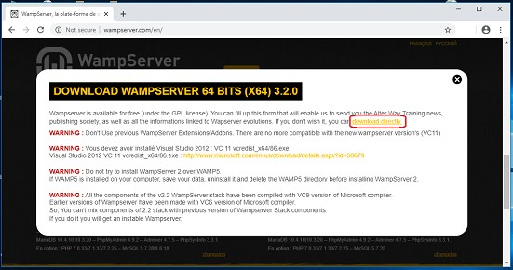

## Step 4

Double-click the downloaded file to launch the WAMP installer.

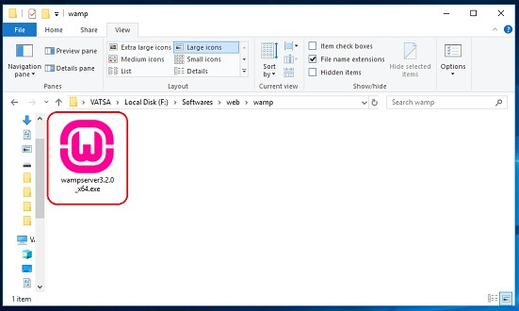

## Step 5

"Select Setup Language" window will appear on the screen and then choose your preferred language.

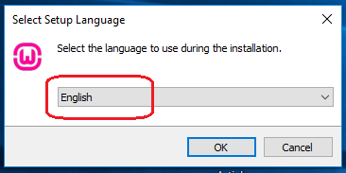

## Step 6

Under the "License Agreement", click on the "I accept the agreement" radio button and then click on the "Next" button.

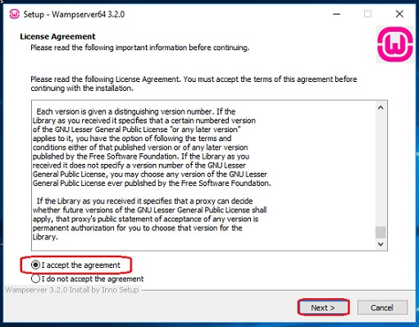

## Step 7

Click on the "Next" button.

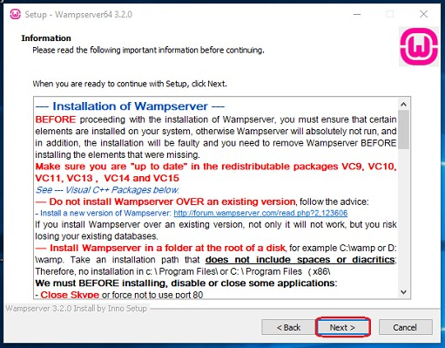

**Note:-**

"Information" setup ensures that the required components (prerequisites) are installed on your system for the Wamp Server to function correctly.

## Step 8

Choose a location (folder) to install the WAMP server and click on the "Next" button.

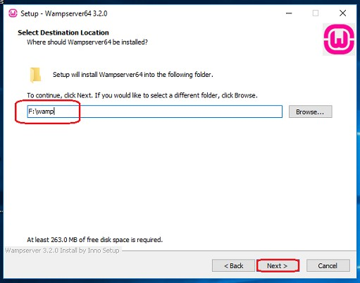

## Step 9

Select the components that you want to install and click on the "Next" button.

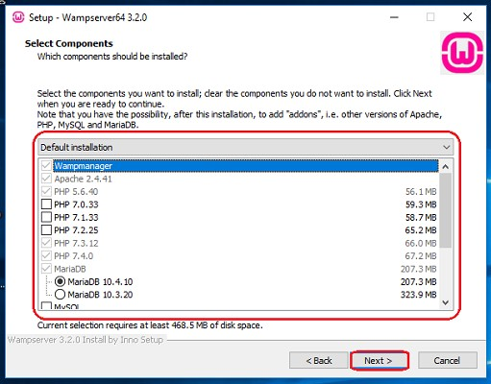

## Step 10

Select the start menu folder

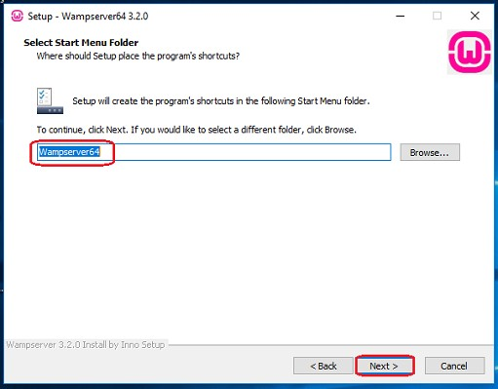

## Step 11

"Ready to Install" window will appear on the screen and then, click on the "Next" button.

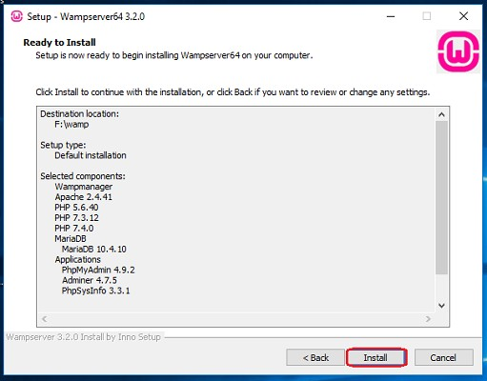

## Step 12

Now, select the default browser and default text editor for the wamp server.

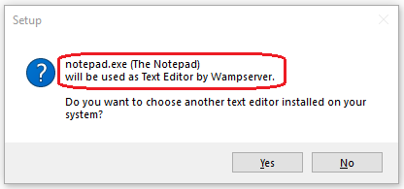

## Step 12

Click on the "Finish" button.

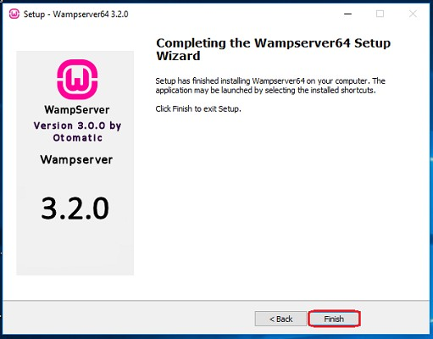

# Configuration Process of WAMP Server

## Step 1

Start the WAMP server through its shortcut on the desktop.

## Step 2

When the WAMP Server starts, you can see the color of the WAMP server icon in the taskbar becomes green. Initially, it will be red, then turn into

amber and then green. When it turns green, it means all the services are now running fine.

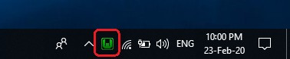

# Fix an Issue of Apache not Working

Some users may face an issue with Apache and MySQL module services not working in WAMP. However, depending on the setup configuration or usage of your system, you may need to change the port number of the Apache and the MySQL. For example, because the "World Wide Web Services" under "Internet Information Services (IIS)" is also run on port 80 in your system, which is also the default port of apache in WAMP. And, the two servers (applications) can not use (run) the same port simultaneously.

Follow the instructions below to fix the problem with Apache and MySQL services in WAMP Server.



## Method 1.

## Change the default port of Apache

## Step 1

Open the WAMP Server.

## Step 2

In Apache Module Service, click on the "httpd.Conf" button.

(If it does not work, go to conf file and change the port according to a free port available in your system)

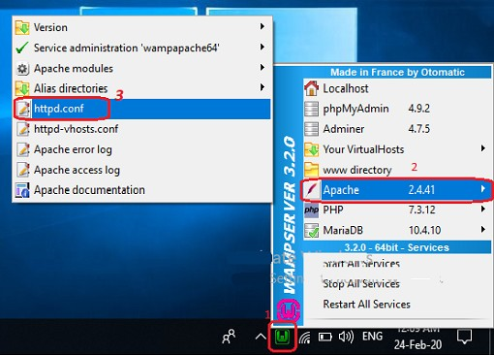

## Step 3

By pressing the "Ctrl + F" key, find the "Listen 80" and replace it with another open port (like 81 or 9080) and save the file.

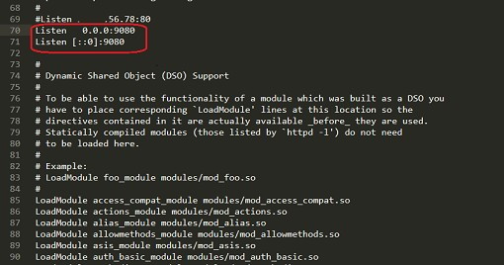

## Step 4

Restart the WAMP Server by clicking on the "Restart All Services" option.

## Step 5

Now, open and check the "WAMPP Server" and also check the localhost and phpmyadmin.



## Method 2.

## By disabling the Internet Information Services

## Step 1

From the Start Menu, search for Control Panel.

## Step 2

Click on "Programs" option.

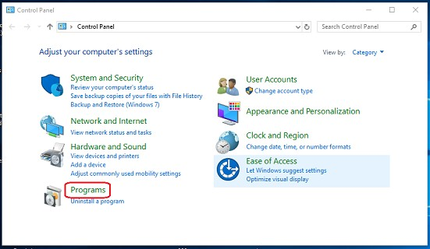

## Step 3

Click on the "Turn Windows Feature on or off" option.

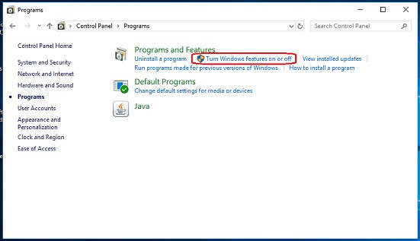

## Step 4

Uncheck (clear) the "Internet Information Services" option and click on the "OK" button.

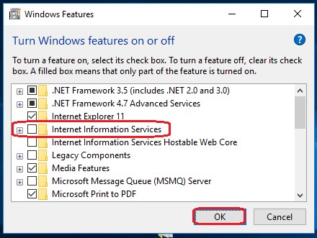

## Step 5

Click on the "Restart Now" option (This will reboot/restart your computer/laptop).

## Step 6

Now, open and check the "WAMPP Server" and check the localhost.



# Conclusion

# By following the above steps, you can install and configure the WAMP server in Windows 10.

You can setup your databases as according to the sql files that will be uploaded on the link.

After setting up the database, the website is good to go.

**USER FLOW OF THE WORKING WEBSITE (SWEET STOP)**

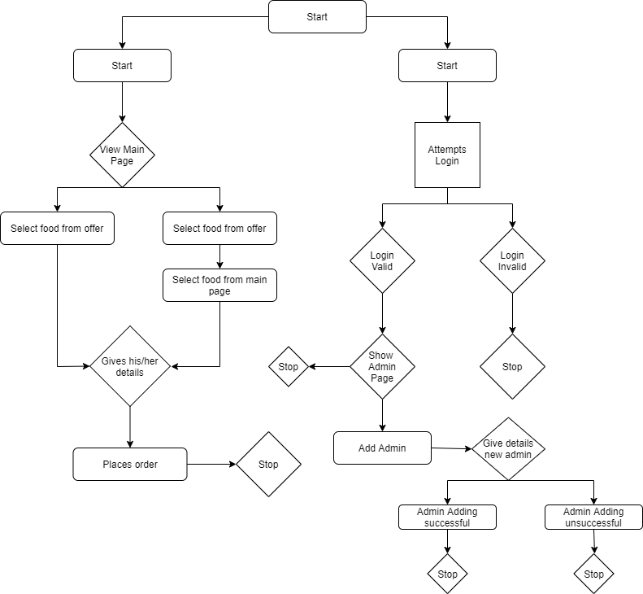

**User flow of the website**

1. As soon as you enter the website, u will find the list of sweets available.



2)Then you can add to cart by choosing the check boxes given to you, under the type of sweet you want.



3) Once you click the buy option, it will ask you to enter the details shown above(Name, Email Id, Address). Then click “Place Order” button.



1. Then it will show you your orders and will the total amount that you should pay. At the bottom, it will also show you the delivery boy allotted to you, who will deliver you the sweets.



1. At the end of the day, the admin can sign-in to see the amount he/she has earned.



The admin must login with correct Name and Password.

1. If the entered credentials are wrong in the Admin Sign-in, then it show the below pop-up.



7) Once you sign-in successfully in the admin page you can view these details.









**Purpose of each page:**

index.php:

Shows the user all the sweets available and also has the option to select the only sweets which have offers.



cart.php:

Asks the user for their details which will be used for order delivery and other such details.

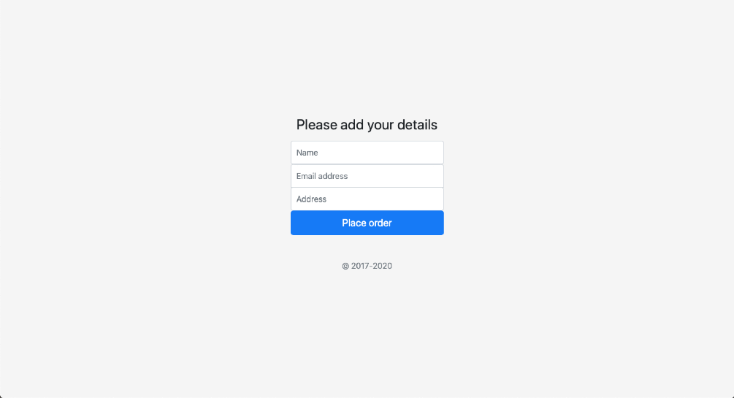

Sign-in/index.php:

Shows the user a summary of their order and sends the order data to sql database

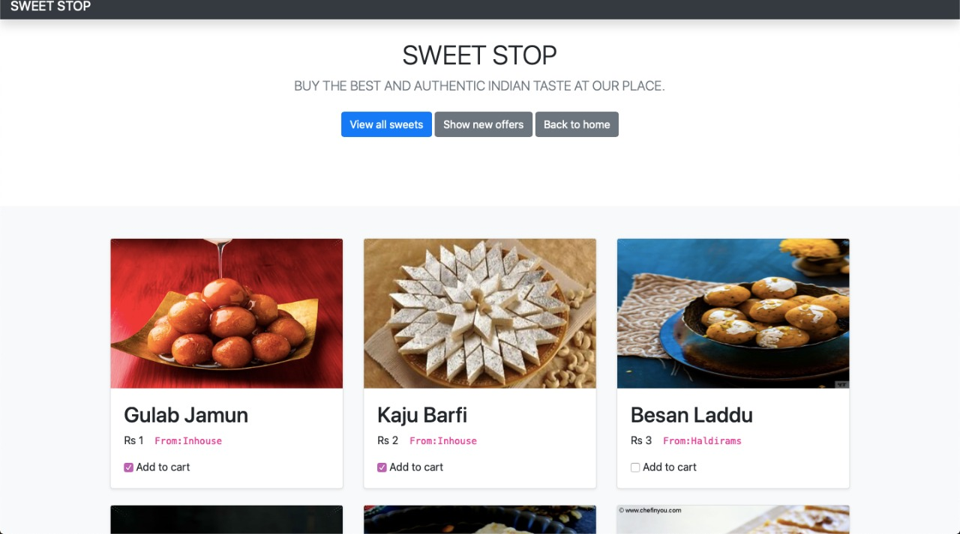

sign-in/sign-in.php:

Used for admin sign-in

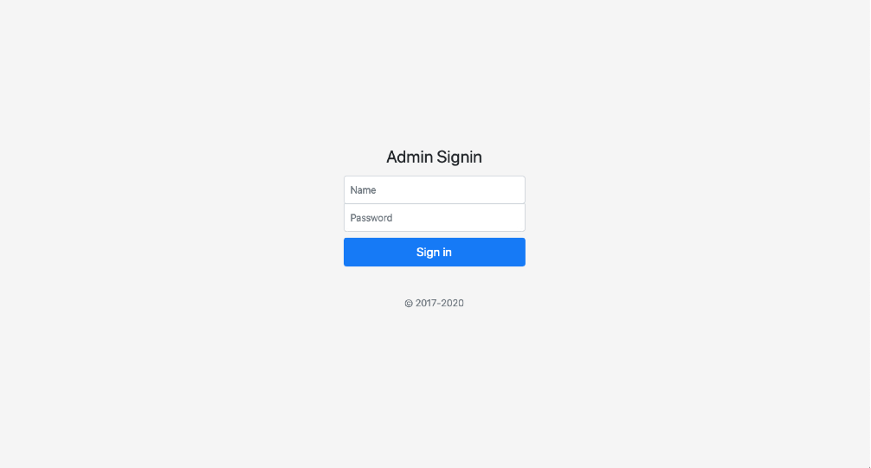

admin.php:

Shows data related to the admin of the shops like total orders, delivery people working and other such data.

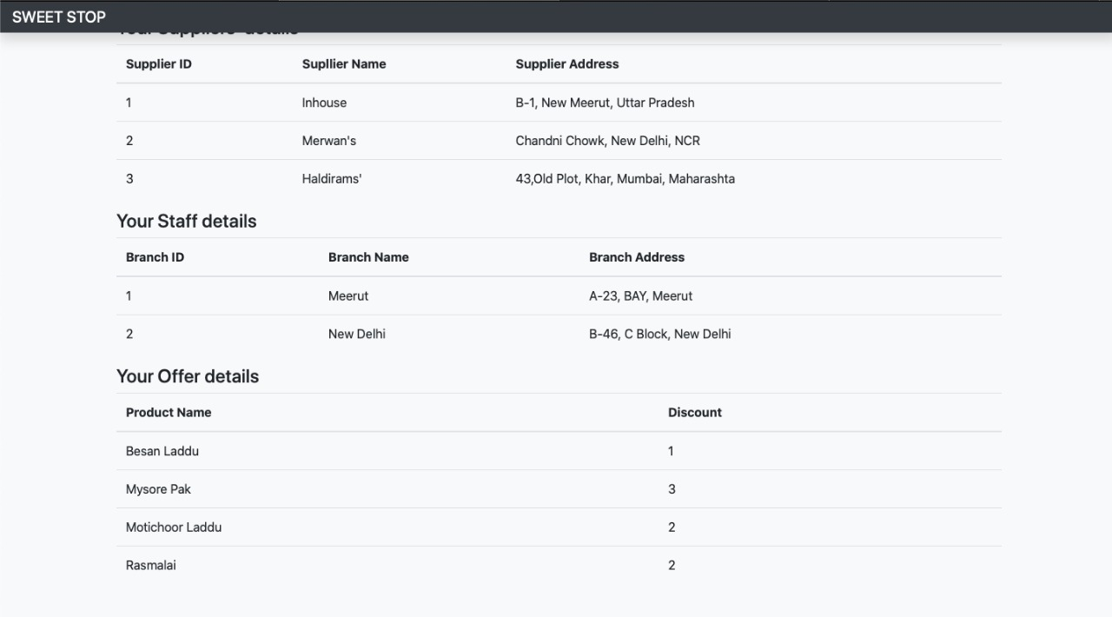

.

1. Explain about your experience during this project in not less than 200 words.

=> This project was very helpful and informative for us to improve our technical skills and give us the experience to make a real time project which used all three basic domains of Web Development i.e, Design, Front End and Back End. In design, we used Adobe Xd, in Front End we used HTML, CSS, JavaScript. In Back End we used MySQL for database and PHP as server-side language. This is the first time we performed back end and it was very new and interesting for us. We were familiar with databases as we were taught SQL in class. PHP was completely new for us and learning it also increased our technical knowledge. This project also helps us understand how an E-Commerce website functions and works. It also helps us understand how difficult it is to maintain records and the how the queries can help us resolve them. In the process of making this website, we learnt how to integrate the different parts of a website as one whole project. This project has shown that Web Development is has many sub-fields in it. Learning Back End was remarkably interesting, and we will try our level best to work on it and improve our skills in it. Integrating SQL and PHP and using them together was the most exciting part. Overall, this project was extremely useful for us and we will enhance it.